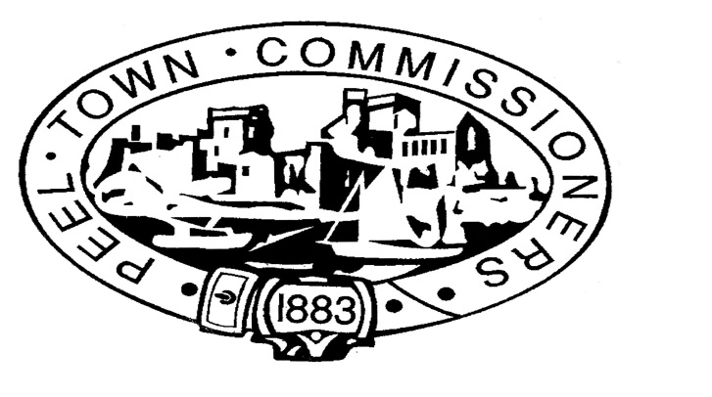

PEEL TOWN COMMISSIONERS
House of Keys Election 2016
REQUISITION MEETING

Following the receipt of a petition from twelve electors in Peel, the Chairman of Peel Town Commissioners has arranged for a public meeting to take place at the Corrin Hall in Peel on Monday 19 September 2016 at 7:00pm

By order of the Chairman of Peel Town Commissioners

Derek Sewell, Town Clerk, Peel Town Commissioners, Town Hall, Derby Road, Peel

